Project Design Phase
Problem – Solution Fit

Date | 30 September 2026
Team ID | SWTID-2026-6733
Project Name | Import Data using Transform Maps (Spreadsheet)
Maximum Marks | 4 Marks

Solution Architecture: Automated Bulk Data Migration via ServiceNow Import Sets & Transform Maps

1. High-Level Architecture Diagram
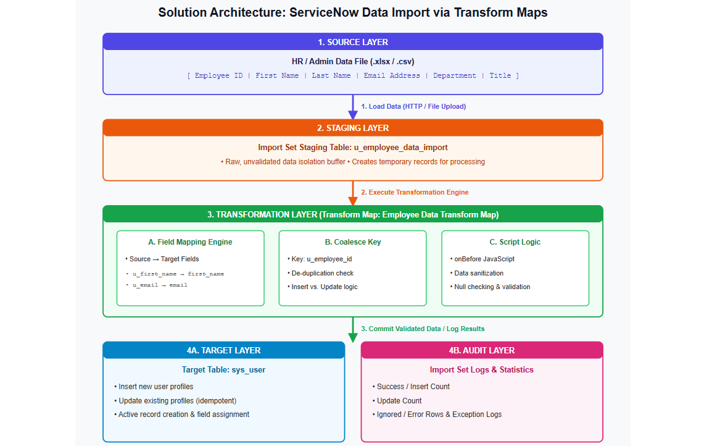

2. Architectural Components & Design Specifications

A. Source Layer (Data Input)
- Format: External Spreadsheet (.xlsx or .csv).
- Source Attributes: Raw employee parameters supplied by HR Operations or System Administrators.
- Role: Acts as the external data payload triggering the ingestion workflow.

B. Staging Layer (Import Set)
- Table Name: u_employee_data_import (Extends sys_import_set_row).
- Design Pattern: Sandbox / Buffer Pattern.
- Purpose: Prevents direct, unvalidated write operations to production tables. If an import fails midway, core database tables remain untouched and uncorrupted.

C. Transformation Layer (Transform Map & Business Rules)
- Transform Map Name: Employee Data Transform Map.
- Target Table: sys_user (or target custom employee table).
- Core Sub-Components:
  - Field Mapping Schema: Maps incoming raw column strings to typed ServiceNow attributes.
  - Coalesce Matching Engine: Configured on u_employee_id. It performs a lookup against the target table before execution:
    - Match Found: Updates the existing record (Prevents duplication).
    - No Match Found: Inserts a brand new record.
  - Event-Driven Transform Script (onBefore): Executes custom JavaScript logic per row before writing to the database:
    - Enforces lowercase formatting and whitespace stripping on email addresses (email.toLowerCase().trim()).
    - Validates mandatory parameters (e.g., skips execution if u_employee_id is null).
    - Automatically sets new user profiles as active = true.

D. Target & Audit Layers (Persistence & Logging)
- Persistence Layer (sys_user): Stores final clean, structured user records.
- Audit & Traceability (sys_import_set_run / sys_import_set_row_error): Logs row-by-row execution outcomes (Inserted, Updated, Ignored, Error) to provide full accountability and quick debugging.

3. Key Non-Functional Requirements (NFRs) Addressed
Architectural Principle | Implementation Strategy
Data Integrity | Isolated staging table (u_employee_data_import) acts as a firewall against table corruption.
Idempotency & De-duplication | Coalesce Key ensures re-importing the same file multiple times updates existing profiles rather than creating duplicate accounts.
Auditability & Traceability | Out-of-the-box ServiceNow Import Set logs record who imported the file, when it occurred, and execution status per row.
Maintainability | Dynamic field mapping and modular onBefore scripts allow developers to easily add new validation rules or attributes without altering schema architecture.

